6. Immune System and Other Defenses *Ch 45*

______________________________________________________________________________

I. Defense Against Pathogens *(1052-1057)*

A. Innate Immunity

B. Adaptive Immunity

II. The Adaptive Immune Response *(1057-1067)*

A. Definitions and Functions

1. Antigens

2. Antibodies

B. Cells of Circulatory, Lymphatic, and Immune Systems

1. Hemopoiesis

2. Differentiation of cell types

3. Lymphoid types

C. Lymphocyte Activation

1. Binding of antigen

2. Clonal selection

3. Effector cells and memory cells

III. Essentials of the Antibody-Mediated Immune Response *(1058-1065)*

A. B Cell Activation and Antibody Production

B. Antibody Structure and Function

C. Antibody-Mediated Response

1. Neutralization

2. Agglutination

3. Precipitation

4. The complement system

D. T Cells and the Antibody-Mediated Immune Response

1. Activation and proliferation of helper T cells

2. Helper T cell stimulation of B cells

IV. Cell‑Mediated Immune Response *(1065-1067)*

A. Introduction

B. T Cell Activation

1. Antigen presenting cells

2. Clonal selection

C. Action of cytotoxic T cells

6-1

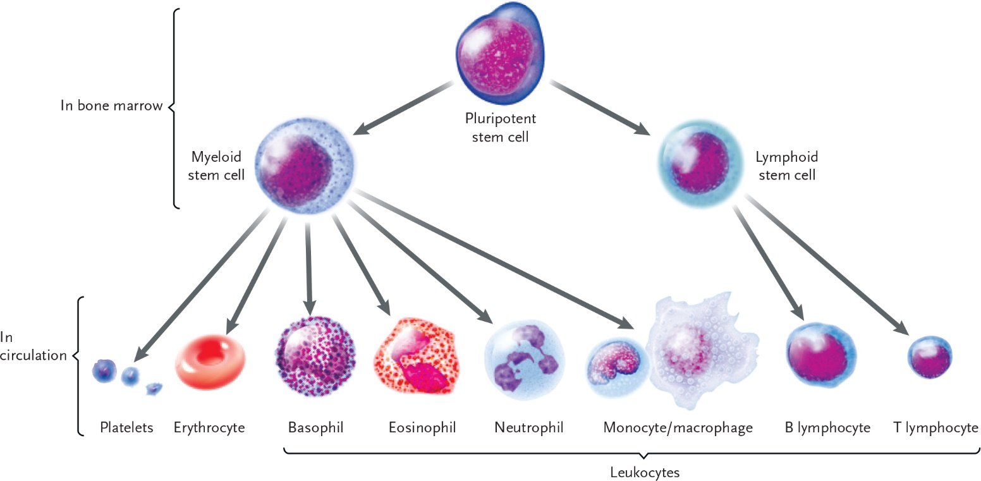

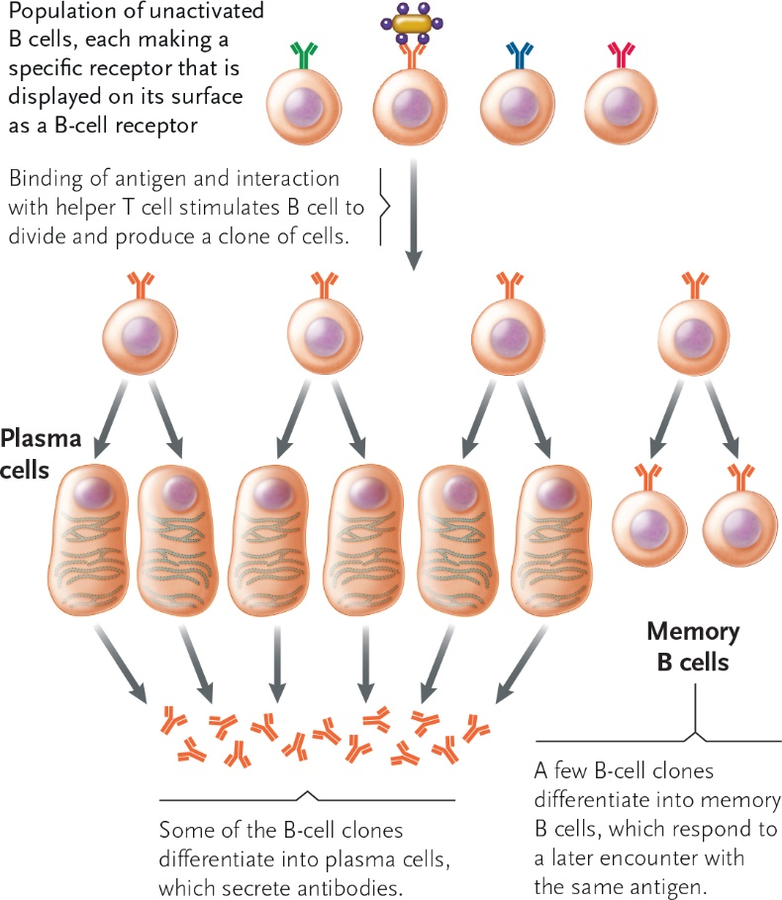

6-2

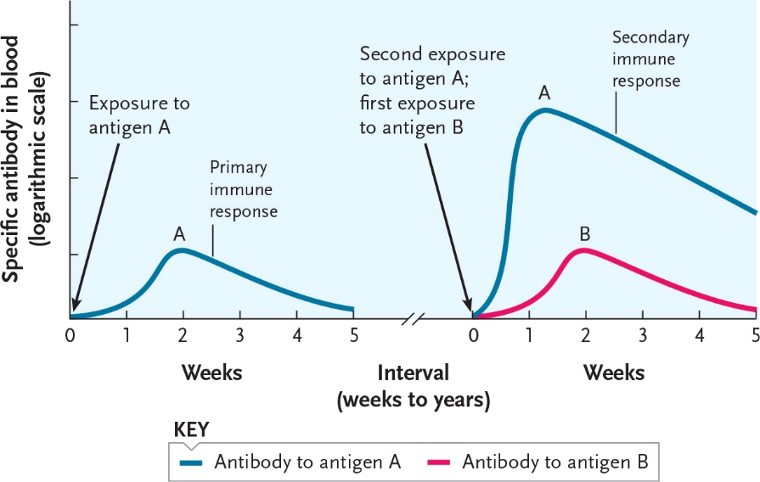

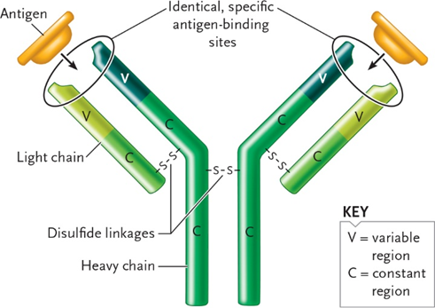

6-3

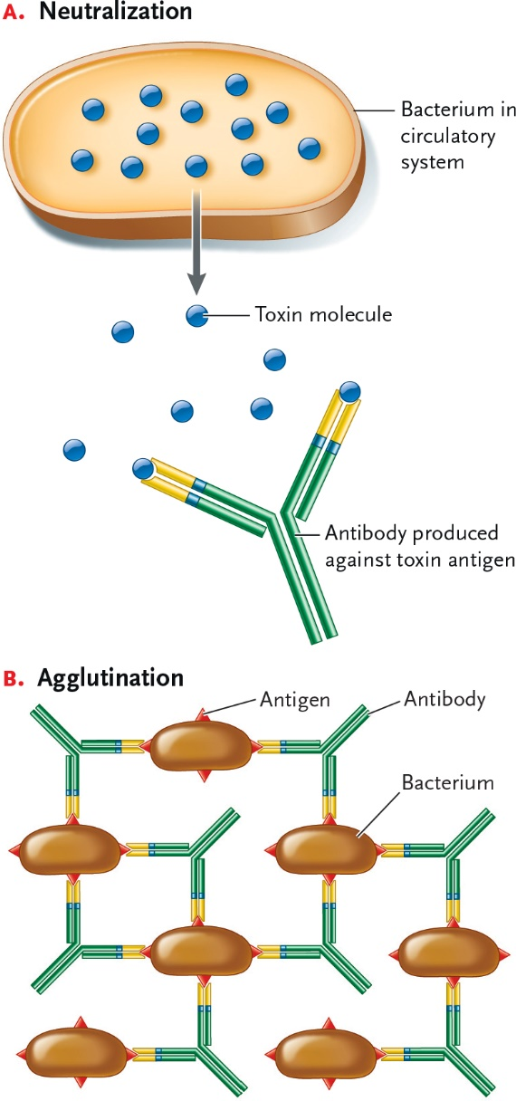

6-4

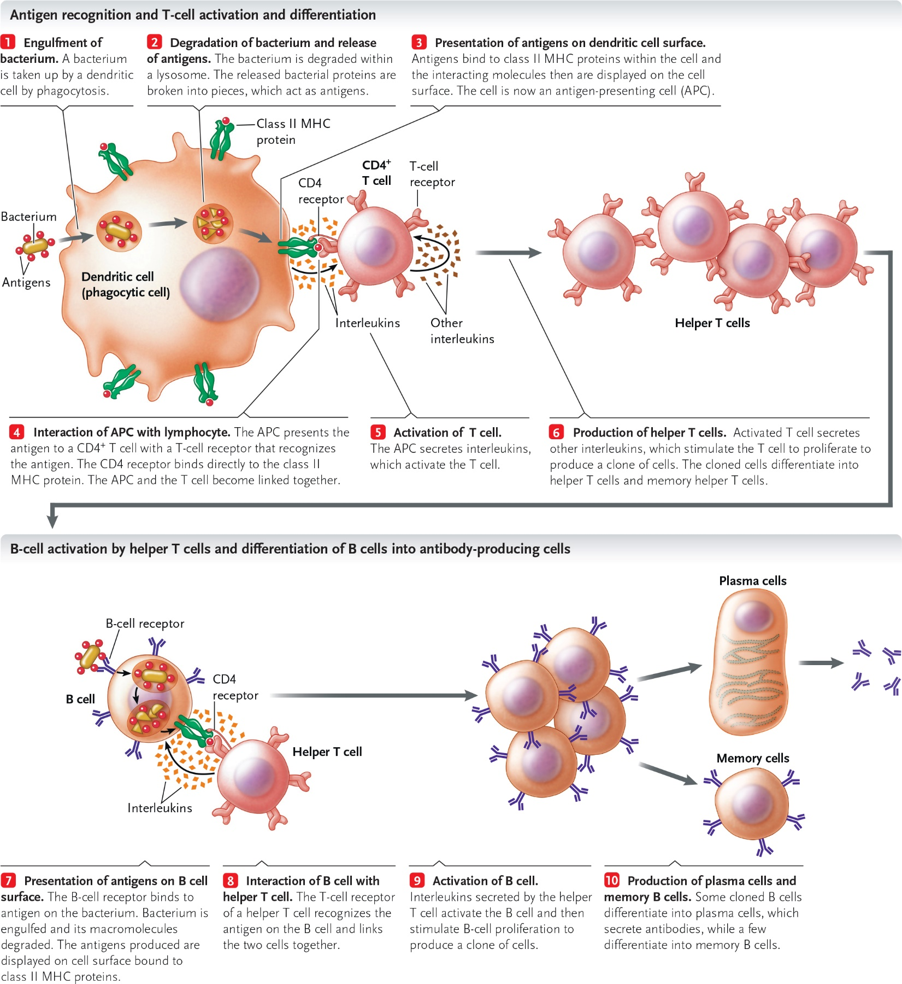

6-5

